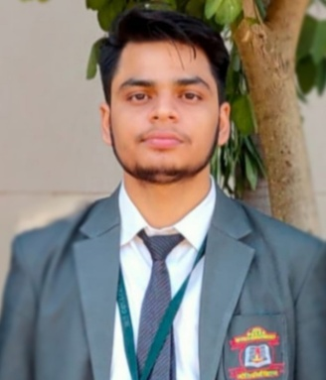

**Name:** Aman Kumar Tiwary

**E-Mail:**tiwaryaman38@gmail.com

**Mobile:** +91-7783880349

**Address:** Sector-B,indrapuri,Bhopal.

**Linked Profile:** <https://www.linkedin.com/in/aman-tiwary-ab4262271>

**Github Profile:** <https://github.com/AMAN-48>

**Netlify Profile:** <https://app.netlify.com/teams/aman-48/sites>

**CARRIER OBJECTIVE**

Motivated and enthusiastic 3rd-year Computer Science student with strong soft and technical skills in Java, frontend development, Oracle, and SQL. .I want To secure an job or entry-level position in the field of IT where I can apply my technical knowledge, problem-solving skills, and passion for innovation to contribute to impactful projects while gaining valuable industry experience.

**EDUCATION**

**Bachelor of Technology in Computer Science**  
[Ies College of Technology] | [Bhopal, MadhyaPradesh]  
Expected Graduation: [june, 2026]

* Current CGPA: [**7.45**]

**Intermediate 10+2**  
[jac Board] | [ Jharkhand]  
completed year: [june, 2022]

* Percentage in 12th[**85.8**]

**10th Board**  
[CBSE] | [Jharkhand]  
Expected Graduation: [june, 2026]

* Percentage in CBSE(10TH):[**77.6**]

**TECHNICAL SKILLS**

* **Programming Languages**: Core and Advance Java, C/C++,Basic Python.
* **Frontend Technology**: HTML5, CSS, JavaScript, Bootstrap,
* **Database Management**: Oracle , SQL,
* **Tools/Software**: Visual Studio Code, IntelliJ IDEA,Netbeans.
* **Version Control**: Git, GitHub.

**PROJECTS**

1. **Employee Management System (Java & oracle)**
   * Implemented functionalities like adding, removing, and searching.
   * Designed and optimized Oracle queries for data manipulation.
2. **Personal Responsive Portfolio Website**
   * Built a personal portfolio website using HTML, CSS, and JavaScript.
   * Ensured responsive design across devices using Bootstrap.
   * Hosted the project on GitHub Pages for live access.

. **EXTRACURRICULAR ACTIVITIES AND INTERESTS**

* **Technical Interest-** Take Participation in coding challenges on such platform like Hackerrank and codechef .
* **Activity**-Coordinated tech fests such as Smart India hackathons at college in dec2024.